**Feedback Management System Documentation**



**Team Members:**

|  |
| --- |
| Team |
| Aman Goel |
| Om Gupta |
| Shubham Bansal |

1. **Introduction**

The Training department of Data global solutions constantly conducts several training programs for the employees’. Collection of feedback and analysis of feedback is a very critical part of any training program.

* As a training department of Data global solutions,
* I want Feedback Management system,
* so that to improve the training execution based on the analysis of feedback reports

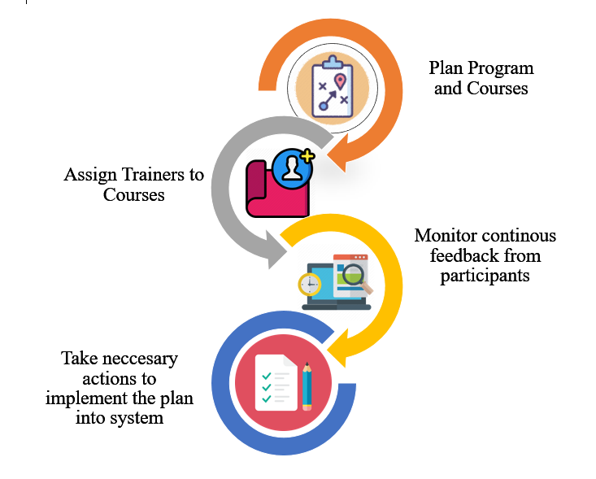

1. **Overview**

This project is aimed at developing an online feedback management system for Data global solutions. The Training department of Data global solutions constantly conducts several training programs for the employees. Collection of feedback and analysis of feedback is a very critical part of any training program. This web application helps the training department to improve the training execution based on the analysis of feedback reports.

Following is a list of functionalities of the system. Wherever, the description of functionality is not adequate; you can make appropriate assumptions and proceed. There are 3 types of users. All users are the employees of the Data global solutions. The functionalities to be performed by the different users are as follows.

* **Training Admin** 
  + Maintain the skill set of faculties
  + Creation/modification/deletion of the Training Programs
  + Maintain the Training courses
  + View the feedback reports and feedback defaulters report
* **Training Coordinators**
  + Creation/modification/deletion of the Training Programs
* **Participants**
  + Enter feedback for the training programs attended

Feedback data is collected from the participants to understand the positives and improvement areas of the training.

Following parameters should be rated by the participants

* Presentation and communication skills of faculty
* Ability to clarify doubts and explain difficult points
* Time management in completing the contents
* Handout provided(Student Guide)
* Hardware, software and network availability

**Rating Terminology**

* **5-Excellent:** “Ideal way of doing it”
* **4-Good:** “No pain areas or concern but could have been better”
* **3-Average:** “There are concerns but not significant”
* **2-Below Average:** “Needs improvement and is salvageable”
* **1-Poor:** “This way of doing things must change”

1. **Epic & Stories**

|  |  |  |  |  |
| --- | --- | --- | --- | --- |
| Epic | Stories | As a/an | I want to | So that .. |
| Feedback  Management System | Add a Training Program | Trainer Admin | Enter the program details and trainer details | A new training program is added to the Training Program database |
| Update a Training Program | Trainer Admin | Change the details entered for the training program | To update the program details |
| Delete a Training Program | Trainer Admin | To delete a training program | Training Program will be deleted from the program database |
| Add a Course | Trainer Admin | Enter the course details and trainer details | A new training course is added to the course database |
| Update a Course | Trainer Admin | Change the details entered for the course | To update the course details or to change the faculty for the course |
| Delete a Course | Trainer Admin | To delete a course | Training Course will be deleted from the course database |
| Add a Faculty | Trainer Admin | Enter new Trainer details | To add new trainer to the Trainer database |
| Delete a Faculty | Trainer Admin | To delete trainer | Trainer will be deleted from the database |
| Add a Student | Trainer Admin | Enter new Student details | To add new Student to the Student database |
| **Epic** | **Stories** | **As a/an** | **I want to** |
| Delete a Student | Trainer Admin | To delete Student | Student will be deleted from the database |
| Add Faculty Skills | Trainer Admin | Enter skill information | To update profile of a trainer. |
| View Feedback Report for all courses | Trainer Admin | Get reports of feedback received. | To see the response towards the course |
| View Feedback Defaulters for all courses | Trainer Admin | To see the  list of students | To fetch the feedback defaulters for each course |
| View Feedback Reports for himself/herself | Trainer | Get reports of feedback received. | To see the response towards the course |
| View Feedback Defaulters for himself/herself | Trainer | To see the  list of students | To fetch the feedback defaulters for his/her own course |
| Provide Feedback | Student | To enter feedback | To submit feedbacks for current course |
| Login into the System | Student, Trainer Admin, Trainer | To input Username and Password | To Login into the Management System |

**5. Use Cases**

**Prerequisite**

1. User must be logged in as admin to perform the add product, edit product and delete product functionalities.
2. Filter Product, Search Product and view Product functionalities can be performed by any user.

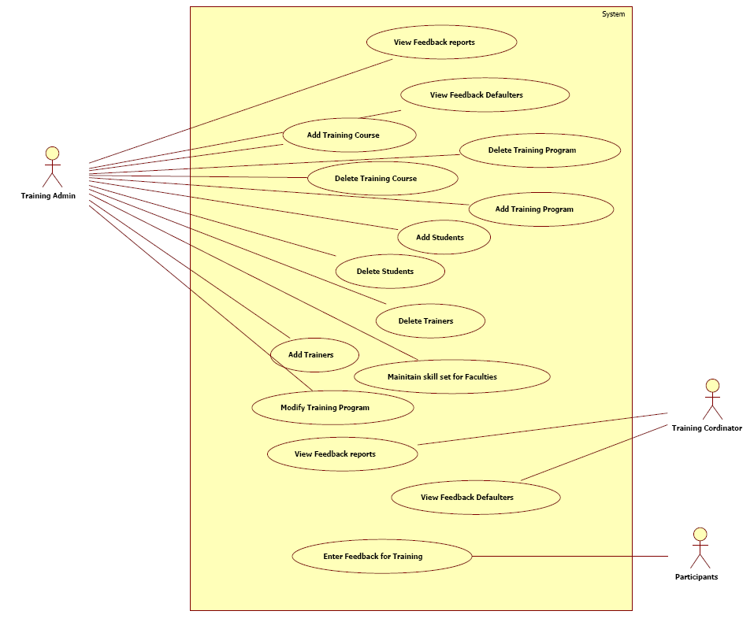Feedback Management Model::Feedback Use Case Diagram (Use Case Diagram)

**5.1 Admin**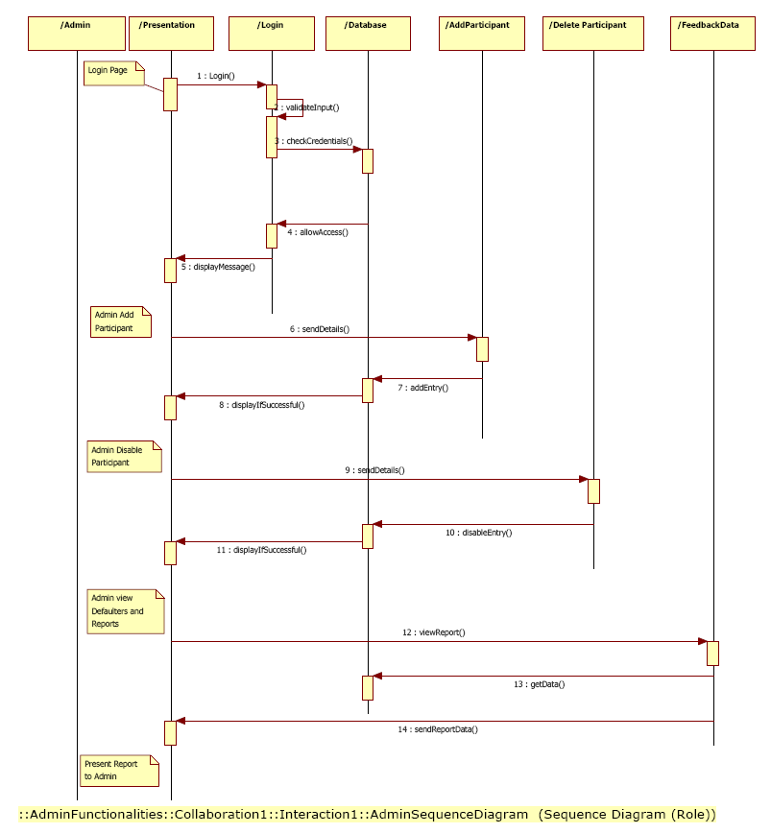

**1. Add Training Course**

Training Courses are Subjects which are provided by to study by trainees/students. Basically, these are setup by the admin. For example, they include Java Full Stack, Java Cloud, Big-Data, Salesforce etc.

The Admin will have the privilege and functionality to add a training course in the list of various other training courses.

**2. Delete Training Course**

A training course can also be deleted by the admin. The admin will first be authenticated and then he will have the functionality to delete a training course using its ID. This will remove the training course from list of various training courses.

There is a point to be noted here that after the training course will be deleted, then the feedback for the relevant training course will not be deleted as such.

**3. Add Students**

The admin will have functionality to add students so that they can provide the feedback for relevant training program. The students added after a feedback for some training program, which has ended, will not be allowed to provide feedback for the same.

It will be asked by admin to provide the training program for which the student is enrolled.

**4. Remove Students**

The admin will have privilege and functionality to remove a student after he/she has completed some training program. After removing student, the respective feedback for the student will stay persistent.

**5. Add Trainer**

Admin will be allowed to add new Trainer and also assign the trainer to some relevant training program. The trainer will also have skillset associated with him/her.

**6. Remove Trainer**

Admin also has the privilege to remove some trainer from the pool of trainers. After removing, the feedback for particular trainer will stay persistent. The training program can have zero or more trainers.

7**. Update Training Program**

Training programs are taught by trainers to the registered students and the training programs can be updated based upon the modules in the training course. Since the technologies taught to students are changing fast and also the students who provide feedback may request the admin to update the training program.

In such cases the training programs can also be updated and new modules can be included inside them.

**8. Maintain Skillsets for Trainers**

Every Trainer who is associated with some training course must have skillset related to that course. Hence the admin will have the functionality and privilege to add new skillset for the trainers that are related to those training programs.

**9. Add Training Program**

Training programs for which the students are enrolled and for which some trainer is associated can also be added to the list to various training program which comes under training course.

The admin will have full privilege to add new training program to the list.

**10. Delete Training Program**

Since the technologies are changing at enormous rate, many technologies becomes obsolete and may not be taught in future. Hence the admin must have functionality to delete training program. But since the feedback for the training program must be persistent and feedback for those training programs will not be deleted.

**11. View Feedback Report**

After collecting the feedback from students about various training program as well as trainers, we can generate the report for the same that will highlight the insights for the effectiveness and success for respective training programs.

**12. View Feedback Defaulters**

Now since the feedback collection needs to be enforced effectively hence it should be visible to admin which students have not submitted the feedback in the given deadline. Hence all such defaulters must be shown to admin in order to request defaulters to submit their feedback.

**5.2 Trainer** 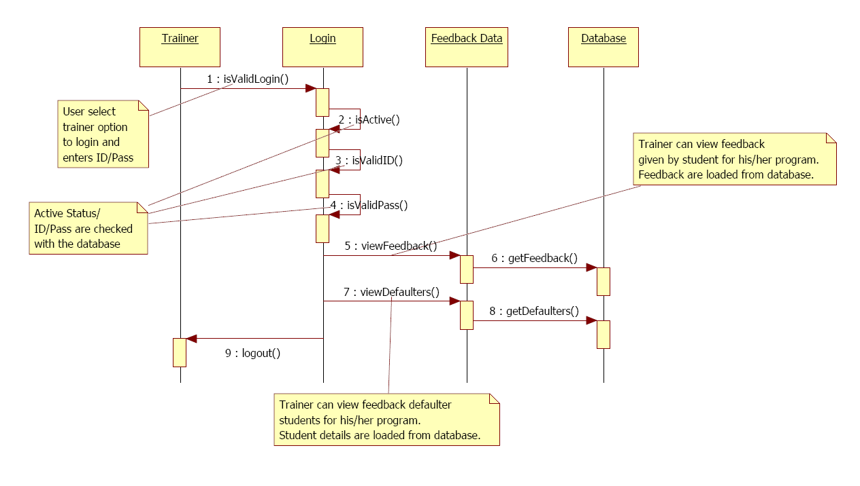

Trainer – Sequence Diagram (Sequence Diagram)

**1. View Feedback Reports**

Since the feedback are used for constructive introspection, hence the feedback for some training program which is being taught by a trainers must be visible as a report to the respective trainers.

**2. View Feedback Defaulters**

Feedback defaulters are students who haven’t provided the feedback for the training program which the trainer is teaching.

**5.3 Student**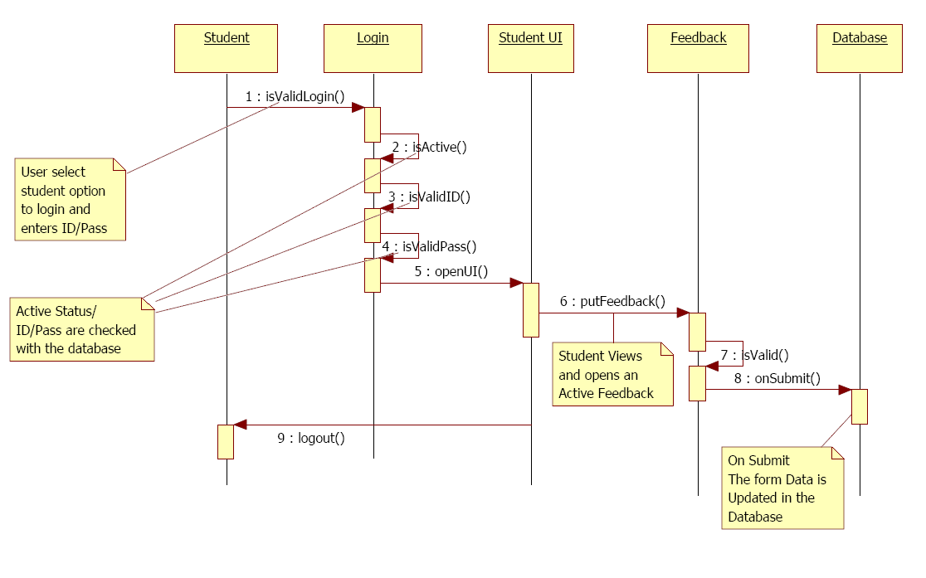

Student – Sequence Diagram (Sequence Diagram)

1. **Enter Feedback for Training Program**

Students will give the feedback for the course he has undergone. He will submit the feedback about the course and the trainer based on certain parameters provided in the form.

**6. Class Diagram**

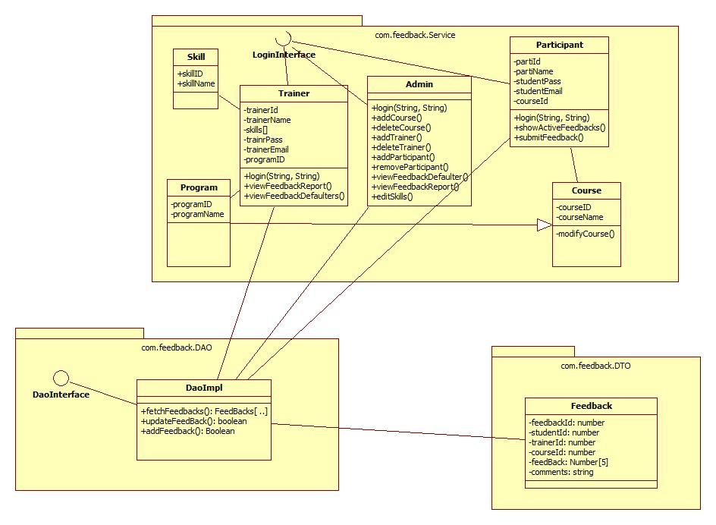

**7. ER Diagram**

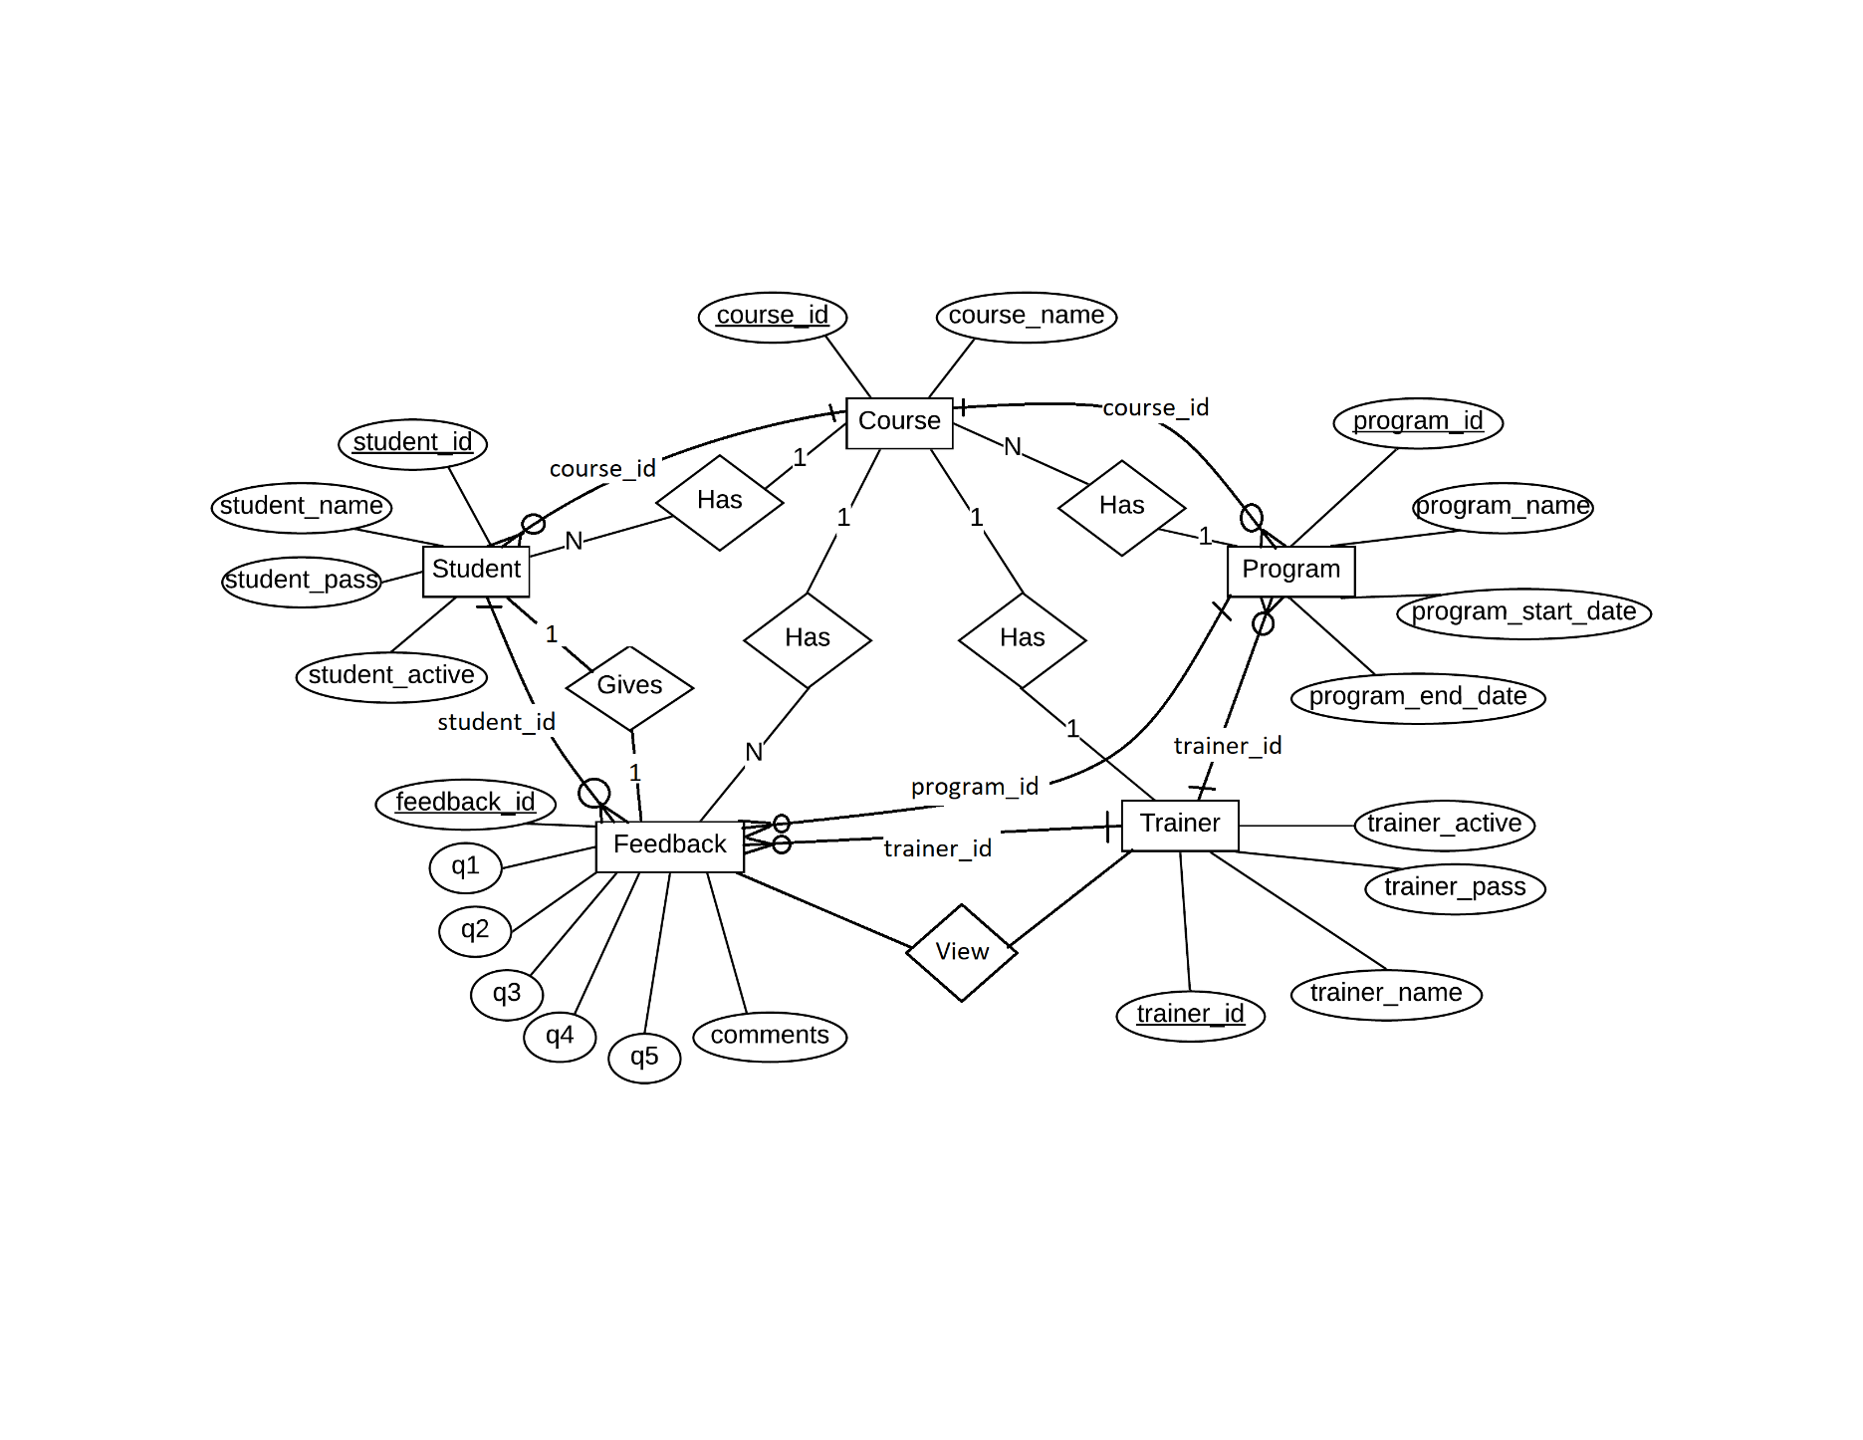

**8. Conclusion**

The conclusion of the project is to collect the feedback from the student about the training program and the trainers engaged. The feedback would help to improve the training program further.